COAL – Guided Notes Name__________________________________________
Interpreting Slope and Y-Intercept
S.ID.7 Interpret the slope (rate of change) and the intercept (constant term) of a linear model in the context of the data.

EQ: How can you use units to help interpret the slope and y-intercept of a line fitted to data?

Interpreting Slope and Y-Intercept of a Line of Best Fit

Let’s look a little more at interpreting the slope and y-intercept of a line of best fit in the context of the situation. **Reminder: In the form y = mx + b, m is the slope and b is the y-intercept

The slope describes how much y changes when x changes by 1 unit. Remember to use the units that are given in the context.

The y-intercept is the y value when x is 0, so in context it is the starting value of y. Since a line of best fit is simply a line used to predict, the y-intercept will not always be relevant, but we analyze it as it is given to us.

Guided Example 1:

The function y = 200x is a good predictor of the cost (in dollars) of a house based on the size (in square feet) of the house.

Step 1: State the slope and interpret it in the context of the problem.

In this function, the slope (m) is 200. This means that the cost of the house (y) increases $200, as the
size of the home (x) increases by 1 square foot. In other words, the cost of the house increases $200 for each square foot.

Step 2: State the y-intercept and interpret it in the context. Explain whether or not it is relevant.

In this function, the y-intercept (b) is 0. This means that the starting cost of the house (y) is $0 when
the size of the house (x) is 0 square feet. In other words, a house with no square footage will cost $0.
This y-intercept is relevant because if the house has no square footage it will not cost anything.

Guided Example 2:

The function y = 5.67x + 4.33 is a good predictor of the minutes spent waiting in line at the bank given the number of people ahead in line.

Step 1: State the slope and interpret it in the context of the problem.

In this function, the slope (m) is 5.67. This means that the time spent waiting in line (y) increases
5.67 minutes, as the number of people ahead in line (x) increases by 1 person. In other words, the time spent waiting increases 5.67 minutes for every one person ahead in line.

Step 2: State the y-intercept and interpret it in the context. Explain whether or not it is relevant.

In this function, the y-intercept (b) is 4.33. This means that the time spent waiting in line (y) is 4.33 minutes when the number of people ahead in line (x) is 0 people. In other words, if no one is ahead in line the wait time would be 4.33 minutes. This y-intercept is not relevant because if no one is ahead of us,
the wait time should be 0 minutes.
You Try!

In each of the following situations, interpret the slope and y-intercept in context. Make sure to explain whether or not the y-intercept is relevant.

1. The Schmidt family is going on a trip. They have written the function y = 58x to represent the miles they have
traveled based on how many hours they have been traveling.

slope:

y-intercept:

2. A zoologist determined the equation y = 0.6x + 0.2 will help predict how many lion cubs will be born in a pride
each year given the number of adult females in the pride.

slope:

y-intercept:

Putting it all together:

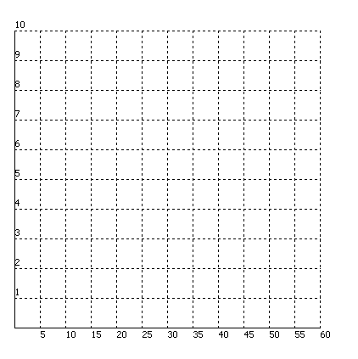
3. The data below shows a person’s age and the number of hours he or she exercises per week. Sketch the scatterplot. Find the line of best fit for the data. Interpret the slope and y-intercept. Show work!

Age, x | Hours, y
18 | 7
26 | 5
32 | 2
38 | 3
52 | 1.5
59 | 1

Line-of-best Fit:

Slope:

Y-intercept:

COAL – Homework Name__________________________________________
Interpreting Slope and Y-Intercept
S.ID.7 Interpret the slope (rate of change) and the intercept (constant term) of a linear model in the context of the data.

EQ: How can you use units to help interpret the slope and y-intercept of a line fitted to data?

In each of the following situations, interpret the slope and y-intercept in context. Make sure to explain whether or not the y-intercept is relevant.

1. Jayden believes the function y = -2x + 43 is a good predictor of how many mistakes a guitarist will make during
a performance based on how many minutes a day he or she practices.

slope:

y-intercept:

2. ABC Tractor company has formulated the equation y = 3.1x – 12 to estimate the amount of time it will take to
mow a field given the size of the field in acres.

slope:

y-intercept:

3. The data below shows the number of years of experience of a car salesman and the number of cars sold each month. Sketch the scatterplot. Find the line of best fit for the data. Interpret the slope and y-intercept. Show work!

Year, x | Cars Sold, y
3 | 5
9 | 14
2 | 12
5 | 21
1 | 8
4 | 15
11 | 22

Line-of-best Fit:

Slope:

Y-intercept:

