COAL B - Guided Notes Representing Data Sets Day 2
Name__________________________________________
S.ID.1 Represent data with plots on the real number line (dot plots, histograms, and box plots).
S.ID.2 Use statistics appropriate to the shape of the data distribution to compare center (median, mean) and spread (interquartile range, standard deviation) of two or more different data sets.
S.ID.3 Interpret differences in shape, center, and spread in the context of the data sets, accounting for possible effects of extreme data points (outliers).

EQ: Why are there different visual representations for data sets?

Method 2: Dot Plot – a frequency plot that shows the number of times a response occurred in a data set, where each data value is represented by a dot or “x.”

Guided Example: We are going to go back to Mr. Jones’ class with the data on the amount of time the students’ grandparents have been married.

55 30 38 48 50 63 41 59 23 51 52 25 52 45 56 50 33 40

Step 1: Just like we always do for statistics, arrange the data in order:

23 25 30 33 38 40 41 45 48 50 50 51 52 52 55 56 59 63

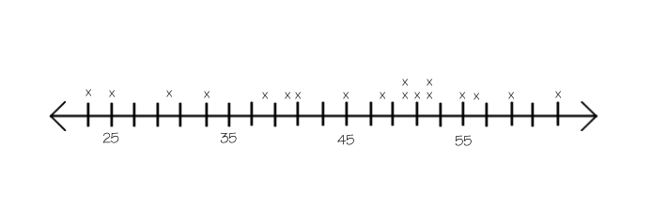
Step 2: Put the data points on the number line using dots or “x.” If a number is repeated 4 times, then 4 dots or
“x’s” should appear.

You try: The following data shows the ages of a group of students graduating from college. Construct a dot plot.
21 23 23 22 22 21 24 20 38 23 22

Ordered list:

Dot plot
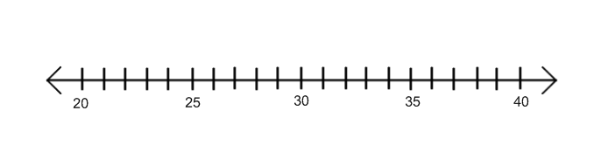

Method 3: Histogram – a frequency plot that shows the number of times a response or range of responses occurred in a data set.

Guided Example: Let’s look at Mr. Jones’ class one more time and the amount of time the grandparents have been married.

55 30 38 48 50 63 41 59 23 51 52 25 52 45 56 50 33 40

Step 1: Arrange the data in order.

23 25 30 33 38 40 41 45 48 50 50 51 52 52 55 56 59 63

Step 2: Based on the given ranges, complete a frequency chart. The frequency is how many times something occurs. For the range 20 – 29, you are looking for how many times a data point occurred from 20 to 29.
Years Married Frequency  20 – 29  30 – 39  40 – 49  50 – 59  60 – 69 | Years Married Frequency  20 – 29 2  30 – 39 3  40 – 49 4  50 – 59 8  60 – 69 1
Step 3: Label the given axes.  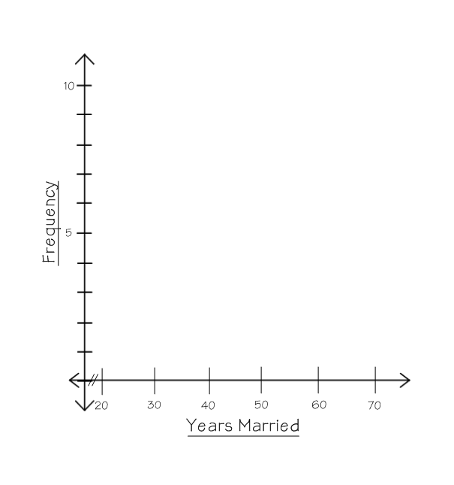 | Step 4: Using the frequencies, construct each bar  to the correct height. Make sure the bars  are connected.  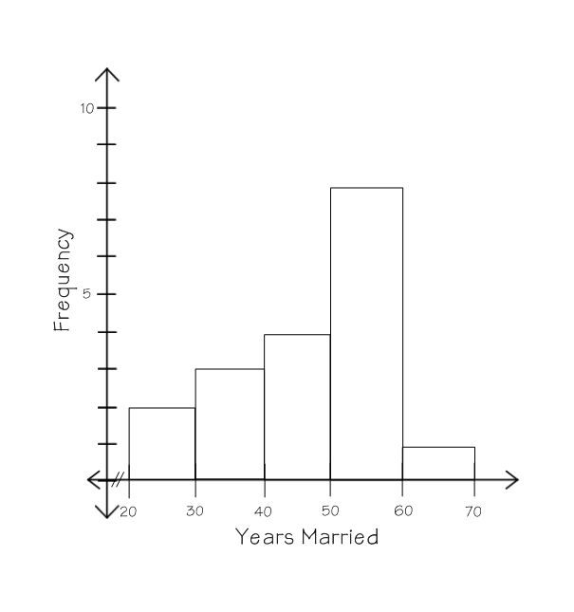

You try: The following data shows the ages of a group of students graduating from college. Construct a histogram.
21 23 23 22 22 21 24 20 38 23 22

Ordered list:
Ages Frequency  20 – 23  24 – 27  28 – 31  32 – 35  36 – 39 | 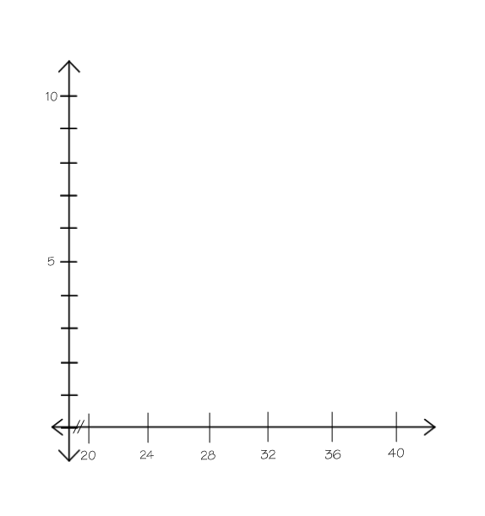
Summary:

Mr. Jones’s class gathered data about the amount of years their grandparents had been married. After gathering the data, they displayed it in 3 different representations.

55 30 38 48 50 63 41 59 23 51 52 25 52 45 56 50 33 40

Box and Whiskers Plot  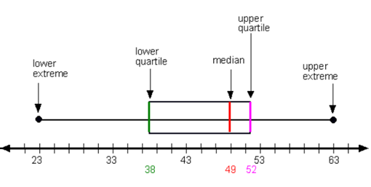 | Dot Plot | Histogram
What differences do you notice in the representations?

The individual points are plotted on a _________________________________.

The _________________________________ is the easiest to see a suspected outlier.

The _________________________________ groups the data into ranges.

The data is equally divided on the _________________________________.

***The data on all of these representations must be _________________________________.

COAL – Homework
Representing Data Sets Day 2

1. Dr. Dawg recorded the weights of the Labrador Retrievers that came into his office one month (rounded to the closest pound). Using this data, construct a box and whiskers plot, dot plot, and histogram.

57 63 90 83 67 63 70 75 70 63 48 82 80 88 72 65 78 81 92

Ordered list:

Box and Whiskers Plot

Median: Q₁: Q₃: LE: UE:
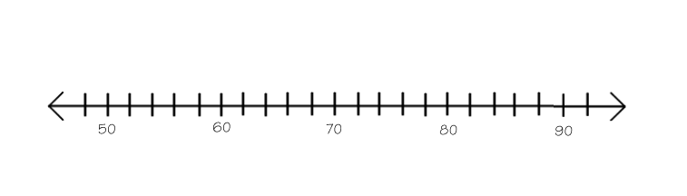

Dot Plot

Histogram  Weight (pounds) Frequency  45 – 54  55 – 64  65 – 74  75 – 84  85 – 94 | 