COAL B - Practice Describing Data Name__________________________________ Date _____________________
S.ID.1 Represent data with plots on the real number line (dot plots, histograms, and box plots).
S.ID.2 Use statistics appropriate to the shape of the data distribution to compare center (median, mean) and spread (interquartile range, standard deviation) of two or more different data sets.
S.ID.3 Interpret differences in shape, center, and spread in the context of the data sets, accounting for possible effects of extreme data points (outliers).

EQ: What do measures of spread describe about a data set?

Part I: Let’s review.

Measures of Center: _______________ and _______________

Measures of Spread: _______________ and _______________

Which center and spread are tied together?

_______________ and _______________

_______________ and _______________

Explain what determines the center to use.

Part II: Practice your skills.

- If the following are test grades for a student calculate the mean and the median. Which measure of center is better and why?
80, 82, 80, 82, 81, 0, 85, 90, 87, 92

Mean = _____

Median = _____

- Students volunteer for two different service groups at the school. In one group the ages are 13, 14, 14, 15, 15, 15, 15, 16, 16, 17 and in another group the ages are 13, 13, 13, 13, 14, 14, 17, 17, 18, 18. Both groups have a mean age of 15. Which group has the larger MAD? What does this number tell you about the data set?

3. A member of the golf team is practicing at the driving range. The distances of his drives are listed
below. Make a box and whiskers plot to display the data.

100 150 75 75 175 125 50 200 100 150 175 250

Ordered list:

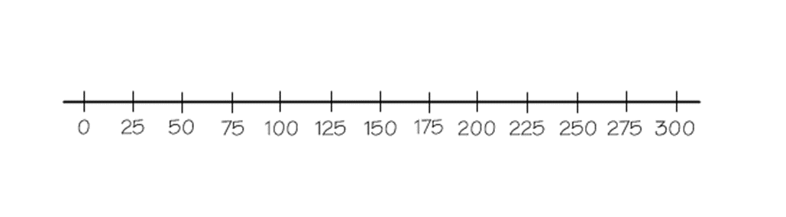 Median: Q₁: Q₃: LE: UE:
Box and Whiskers Plot

4. Calculate and compare the IQR for these two data sets showing the number of service hours completed by members of two different organizations. Which group has a smaller IQR?

Student Council
3.5 4 4 4 4 4 5 6 6.5 7.5 10 13.5

Environmental Action Club
3.5 3.5 4 4 4 4 5 6 6 6 6 7 7.5 8

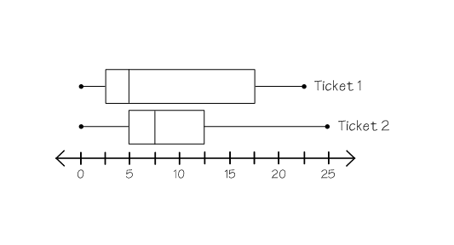5. The following box and whisker plots show the winnings for 2 different types of lottery tickets. Which
ticket has less consistent winnings? How do you know?

COAL B – Ticket/Quiz Describing Data
Name__________________________________________

1. Nutritionists recommend a diet that is low in fat. You can read package labels to find the approximate fat
content of many foods.
Breads and Crackers | Fat content per serving*(g)
Cracked wheat bread | 0.9
Whole wheat bread | 1.1
Pita bread | 0.6
Matzo | 0.3
Graham cracker | 0.5
Rice cake | 0.3
Tortilla | 1.1
Bran muffin | 5.1
Rye bread | 0.9
Pumpernickel bread | 1.1

Would mean or median be the best center to describe the data and why?

2. On five different tanks full of gas a pickup got 12, 14, 17, 12, and 15 miles per gallon. If 14 is the mean miles per gallon, what is the MAD? You MUST show work for credit.

MAD: _____

3. The following data gives the number of goals for two hockey teams. Determine the median and IQR for each.

Penguins: 0 0 0 2 1 2 2 1 2 6 5 2 5 2

Ducks: 0 0 0 1 1 2 2 2 3 3 3 4 5

Penguins: Median = _____ IQR = _____ Ducks: Median = _____ IQR = _____

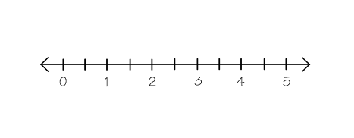4. Make a box and whisker plot using the Ducks scores.
Median: Q₁: Q₃: LE: UE:

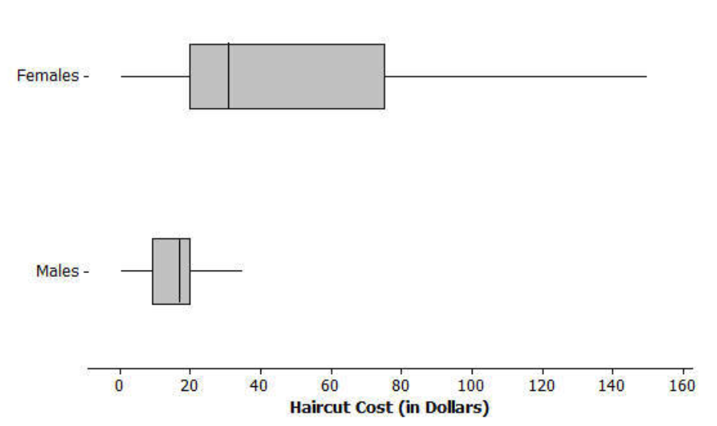5. Using the box and whisker plots on the right, which
haircut cost is more consistent? Explain.

