COAL B - Guided Notes Representing Data Sets Day 1
Name__________________________________________
S.ID.1 Represent data with plots on the real number line (dot plots, histograms, and box plots).
S.ID.2 Use statistics appropriate to the shape of the data distribution to compare center (median, mean) and spread (interquartile range, standard deviation) of two or more different data sets.
S.ID.3 Interpret differences in shape, center, and spread in the context of the data sets, accounting for possible effects of extreme data points (outliers).

EQ: Why are there different visual representations for data sets?

Warm – up: Two science classes boiled water for an experiment. Using the tables, answer the questions.

Class 1  Student Time in seconds  A 61  B 58  C 56  D 60  E 57  F 63  G 65  H 62 | Class 2  Student Time in seconds  A 55  B 68  C 64  D 51  E 60  F 50  G 49  H 60  I 52

1. Which class has a shorter average boil time?

2. Which class has a higher median boil time?

3. Using your knowledge about outliers (deviations) in the data, what is your best measure of center and spread? Explain your answer.

4. Find the MAD for Class 1.

5. Find the IQR for Class 2.

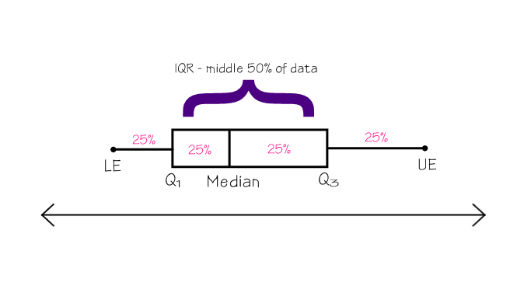Now we are going to look at 3 ways to visually represent the data using graphs.
Method 1: Box and Whiskers Plot – Helpful when comparing 2 sets of data.

A box and whiskers plot divides data into
4 equal sections.

Given 100 data points, each section would include 25 data points (25%). The IQR would have 50 data points (50%). Answer the following questions.

If there were 20 data points, how many would be in each section?
How many would be in the IQR?

Guided Example: Mr. Jones wanted to make a box and whisker plot with his students to see the median amount of time their grandparents had been married. The following is the data:
55 30 38 48 50 63 41 59 23 51 52 25 52 45 56 50 33 40

Step 1: Put the data in numerical order.
23 25 30 33 38 40 41 45 48 50 50 51 52 52 55 56 59 63

Step 2: Find the median: 49
23 25 30 33 38 40 41 45 48 50 50 51 52 52 55 56 59 63

Step 3: Find the Q₁ and Q₃: Q₁ = 38 and Q₃ = 52
23 25 30 33 38 40 41 45 48 50 50 51 52 52 55 56 59 63

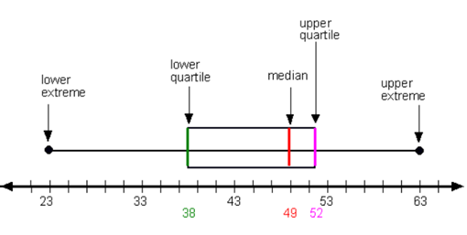Step 4: Find the lower extreme (minimum value) and upper extreme (maximum value): LE = 23 and UE = 63
23 25 30 33 38 40 41 45 48 50 50 51 52 52 55 56 59 63

Step 5: Construct the box and whiskers plot on a number line.

You try: The following shows the ages of a group of students graduating from college. Construct a box and whiskers plot. 21 23 23 22 22 21 24 20 38 23 22

Ordered list:

Median: Q₁: Q₃: LE: UE:
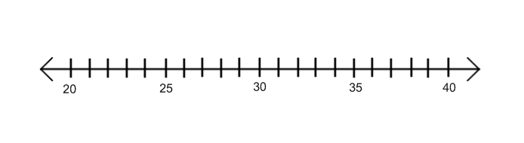
Box and Whiskers Plot

Comparing Data using Box and Whiskers Plot

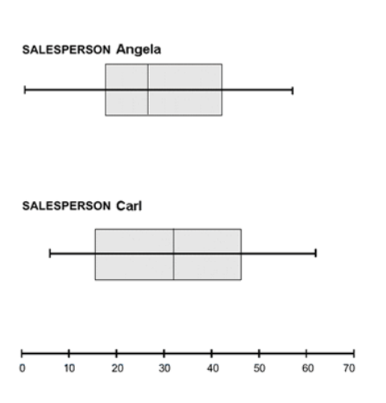A year ago, Angela began working at a computer store. Her supervisor asked her to keep a record of the number of sales she made each month. Carl, Angela’s co-worker, also kept a record of his monthly sales for the year.
Angela’s #  of sales | Carl’s #  of sales
37 | 51
47 | 17
1 | 25
15 | 39
57 | 7
24 | 49
20 | 62
11 | 41
19 | 20
50 | 6
28 | 43
37 | 13

a. What is Angela’s lowest sales figure? __________ Carl’s? __________

b. What is Angela’s highest sales figure? __________ Carl’s? __________

c. How do Angela’s and Carl’s median sales figures compare?

d. Do the results of this data suggest that Angela’s or Carl’s sales are more consistent?
Explain your answer.

COAL – Homework Name________________________________
DAY | BLOOD SUGAR LEVEL
1 | 109
2 | 115
3 | 89
4 | 92
5 | 106
6 | 101
7 | 98
8 | 94
9 | 107
10 | 93
1. Aaron has diabetes, and needs to monitor his blood sugar level. He measures his blood sugar each day before he eats dinner. Aaron's results for the past 10 days are in the table below. Blood sugar levels for any person before meals should be between 80 and 120.

Ordered list:

Median: Q₁: Q₃: LE: UE:

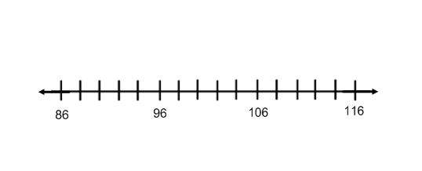Box and Whiskers Plot

2. Using box and whiskers plots, compare the Falcons’ scores this season (40, 27, 27, 30, 24, 23, 30, 19, 27, 23) and 49ers’ scores this season (30, 27, 13, 34, 45, 3, 13, 24, 24, 32).

Falcons 49ers
Ordered list: Ordered list:

Median: Q₁: Q₃: LE: UE: Median: Q₁: Q₃: LE: UE:

Box and Whiskers Plots

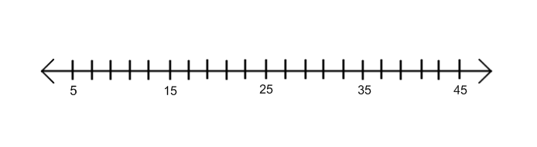

a. What is the Falcons’ lowest score? __________ 49ers’? __________

b. What is the Falcons’ highest score? __________ 49ers’? __________

c. How do the Falcons’ and 49ers’ median scores compare?

d. Based on the box and whiskers plots, which team is less consistent?
Explain your answer.

